**Ford EQ Tool User Manual**

**V1.0**

1. **Installing the tool**

* Matlab Runtime 9.2 must be installed before running the Ford EQ Tool exe. This can be found on Mathworks site.
* Run the exe file (it will take a long time to boot up the very first time it is run).

1. **Creating a project**

* When creating a new project, the following window will show up:

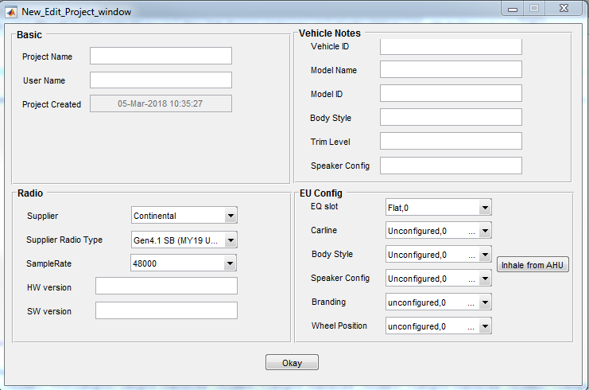

* Select the appropriate Supplier and Supper Radio Type.
* The EU Config section is only required for flashing vbf files for radios that follow the EU IDS (Infotainment Diagnostic Specifiction).
* The rest of the fields do not need to be populated, but allow for additional data to be stored as part of the project for easier project managing.
* Hit Okay to launch the tool

1. **The Main GUI Window and layout**

For Dirana implementations:

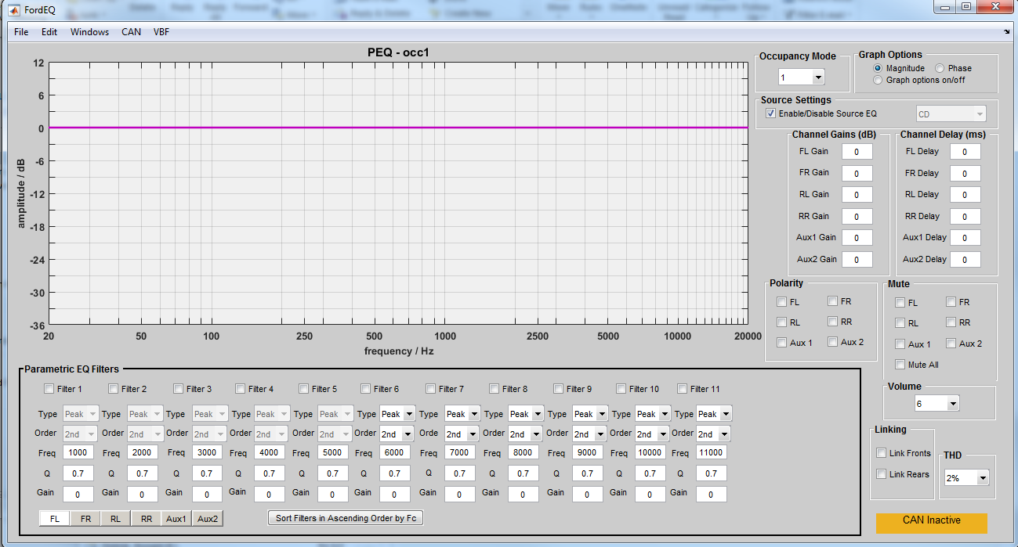

For Hero DSP implementations:

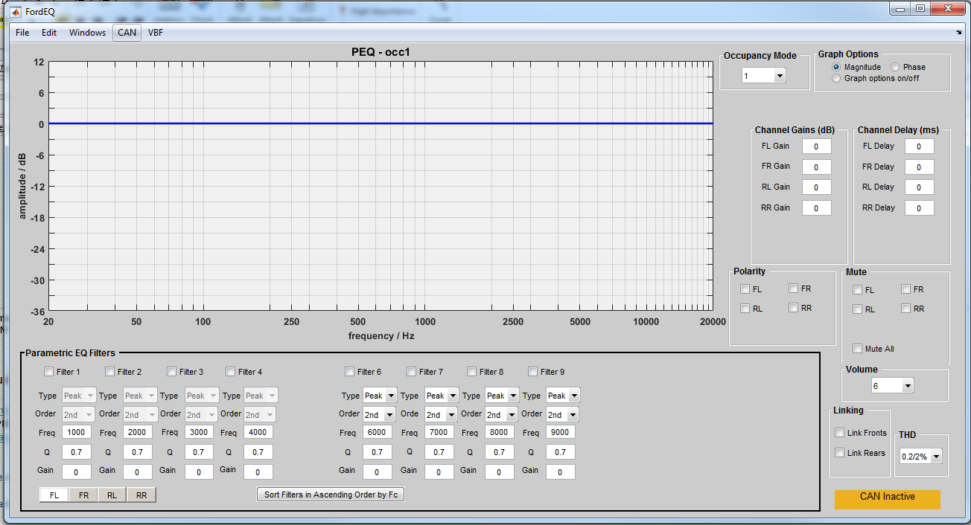

For any other DSP implementations:

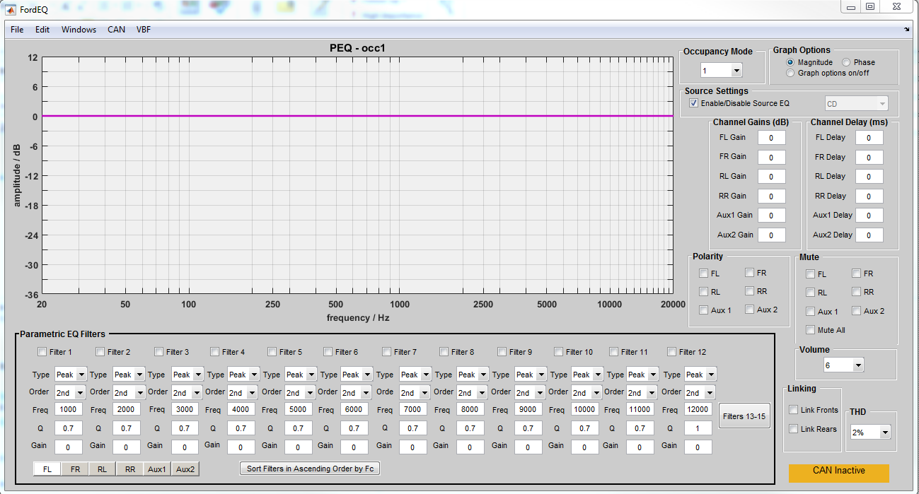

* The main graph shows the frequency response of each of the channels with the parametric EQ filters.
* Pressing the channel buttons at the bottom left of the GUI will load the different filter banks for each of the channels
* The border of the filter bank will change colors depending on the channel. The color corresponds to the color of the frequency response on the graph. The channel colors are:
  + FL = Black
  + FR = Red
  + RL = Green
  + RR = Blue
  + Aux1 = Yellow
  + Aux2 = Purple
* Based on the Dirana implementation, each channel has the following filters (all double precision) available:
  + FL
    - 5 peaking only filters, 6 full-blown filters
  + FR
    - 5 peaking only filters, 6 full-blown filters
  + RL
    - 5 peaking only filters, 6 full-blown filters
  + RR
    - 5 peaking only filters, 6 full-blown filters
  + Aux1
    - 8 full-blown filters
  + Aux2
    - 9 full-blown filters
* Based on the Hero implementation, each channel has the following filters (all double precision) available:
  + FL
    - 4 peaking only filters, 4 full-blown filters
  + FR
    - 4 peaking only filters, 4 full-blown filters
  + RL
    - 4 peaking only filters, 4 full-blown filters
  + RR
    - 4 peaking only filters, 4 full-blown filters
* Based on any other DSP implementation, each channel has the following filters (all double precision) available:
  + FL
    - 15 full-blown filters
  + FR
    - 15 full-blown filters
  + RL
    - 15 full-blown filters
  + RR
    - 15 full-blown filters
  + Aux1
    - 15 full-blown filters
  + Aux2
    - 15 full-blown filters
      * Filters 13-15 for each channel are available in another window that will pop-up if the “Filters 13-15” button is pressed
* If checked, the link fronts button will copy any change to the filters, channel gains, delays, polarity, and mutes done on FL to FR
* If checked, the link fronts button will copy any change to the filters, channel gains, delays, polarity, and mutes done on RL to RR
* The checkboxes above each of the filters will mute the filter (unchecked = unmuted, checked = muted)
* The channel gains and delays will be applied to each channel as entered
* The polarity checkboxes are unchecked = normal, checked = reversed
* The mute checkboxes are unchecked = unmuted, checked = muted
* The occupancy mode dropdown will change the occupancy mode
* The graph options section allows the user to select between the magnitude and phase response
  + The graph options on/off button will bring up a menu to remove channels from the graph, include the occupancy EQ in the freq response, include the source EQ in the freq response, or change the magnitude limits (y-axis)

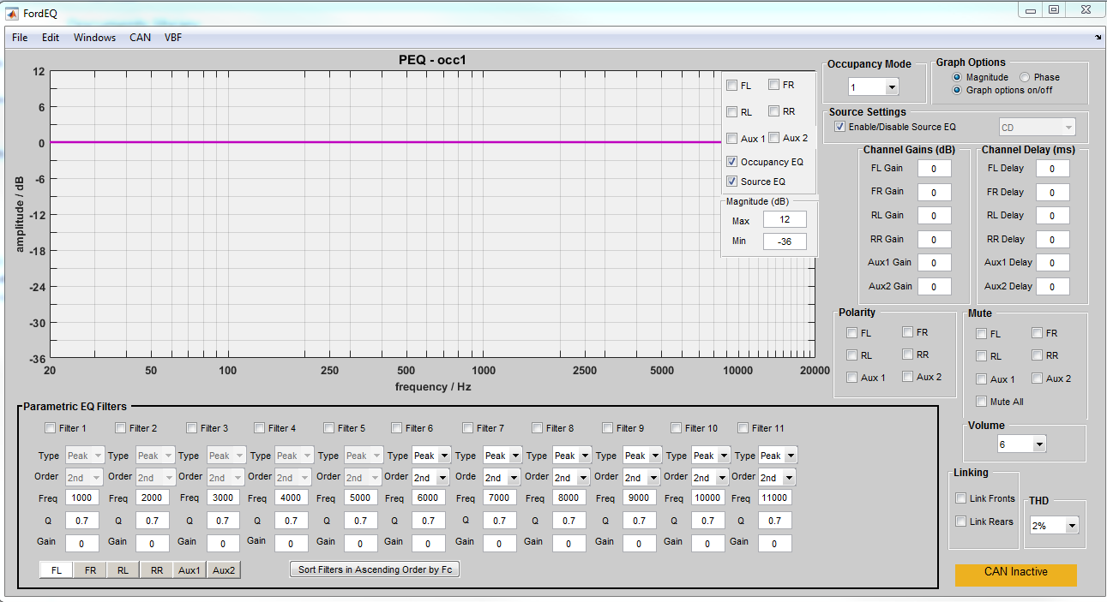

* The Source Settings section
  + If the Enable/Disable Source EQ checkbox is checked, no CAN messages will be sent when change the source EQ filters. If unchecked and the source in the dropdown matches the source in the Source EQ window, the CAN messages will be sent if connected to CAN

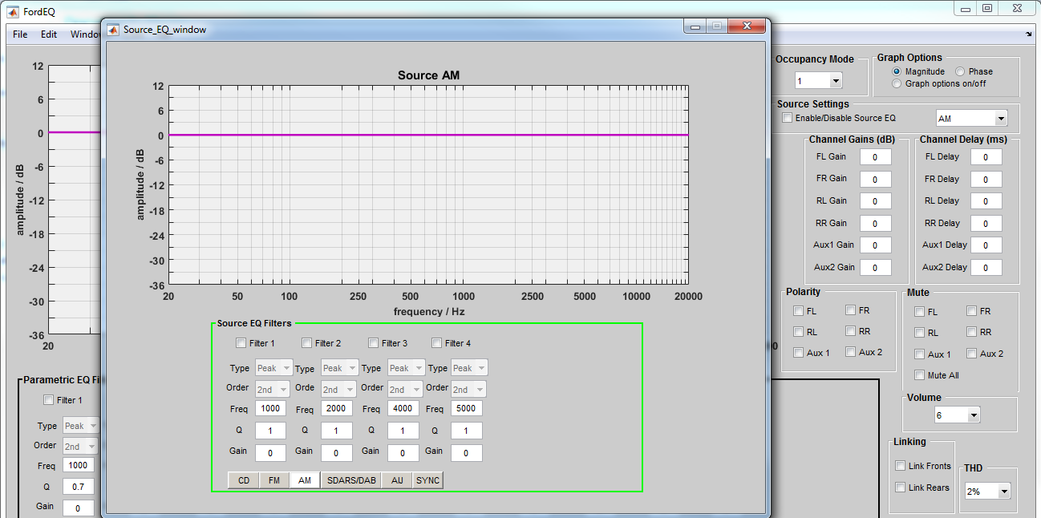

* The volume setting
  + The volume dropdown will send the corresponding volume step request to the radio.
  + The volume dropdown will not reflect any volume changes made in the vehicle by changing the volume knob.
* The THD setting
  + The THD dropdown will change the THD setting associated with the power IC (or ICs). This dropdown will be populated with the correct values per supplier and supplier radio type. If there are two power ICs and they have different settings, they will be listed as x/y where x correspond to the main power IC THD setting and y corresponds to the aux power IC THD setting.

1. **Windows**

* Stereo Filters (only available for Dirana and Hero implementations)
  + The stereo filters window contains a pair of filters that are applied to both FL and FR and a pair applied to both RL and RR
  + GPF0 and GPF1 are applied to FL and FR
  + GPR0 and GRP1 are applied to RL and RR

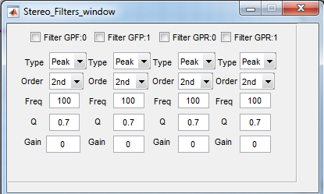

* Limiters
  + The limiter settings are displayed in this window.
    - Front/Rear applies the settings to FL, FR, RL, RR
    - Center applies the settings to Aux2
    - Sub applies the settings to Aux1
  + If unchecked, the limiter settings are applied. If checked, the limiters are turned off

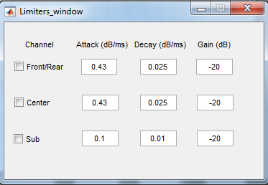

* Input/Source EQ (not available for Hero implementations)
  + For Dirana implementations:
    - The source EQ is a set of 4 filters. The first two filters are double precision. The last two filters are single precision. They are all limited to peaking only. These filters are applied to all channels.

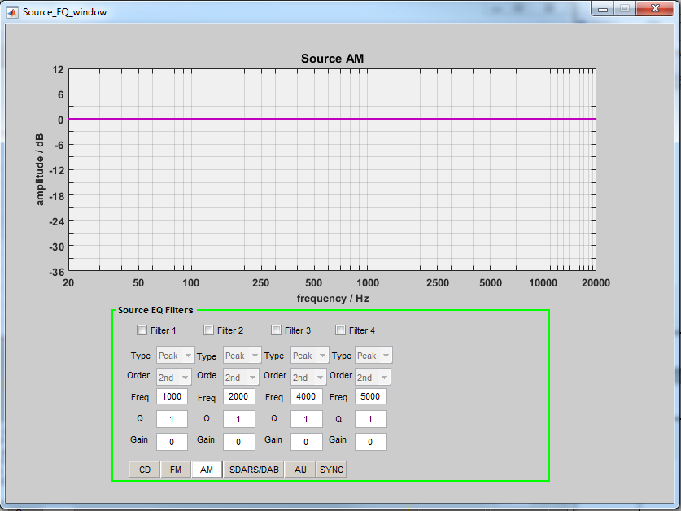

* + For any other DSP implementations:
    - The source EQ is a set of 6 filters. They are all double precision full-blown 2nd order filters. These filters are applied to all channels.

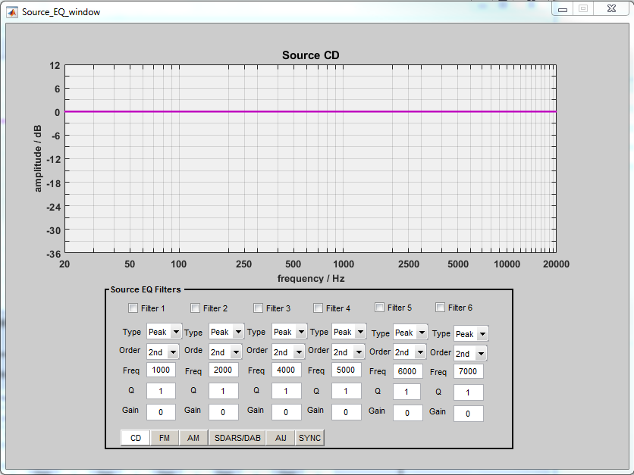

* + This bank of filters will be loaded based on source changes from the EQ vbf file created.
  + For live-tuning, only the most recent settings sent to the radio will be applied.
  + The freq responses in the graph colors match the border of the filter settings and are as follows:
    - CD = Black
    - FM = Red
    - AM = Green
    - SDARS/DAB = Blue
    - AIJ = Yellow
    - SYNC = Purple
* Occupancy EQ
  + For Dirana implementations:
    - The occupancy EQ filters are a set of 5 filters. The first 3 filters are double precision. The last 2 filters are single precision. They are limited to peaking only. These filters are applied to all channels.

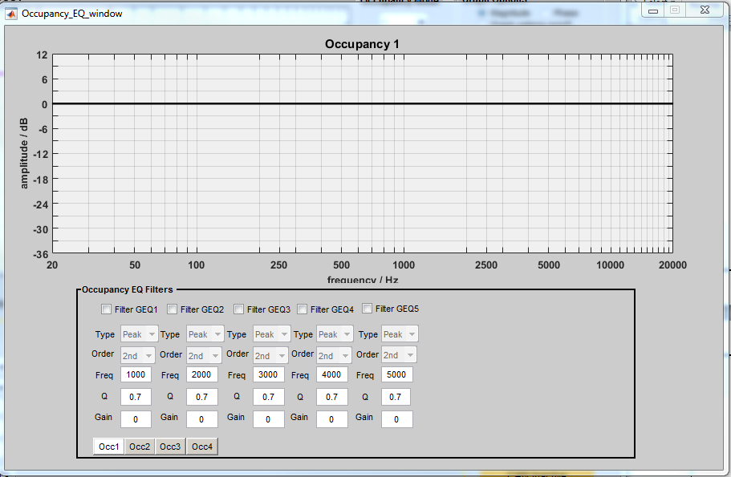

* + For Hero implementations:
    - The occupancy EQ filters are a set of 6 filters. The first 3 filters are double precision. The next 2 filters are single precision. They are limited to peaking only. The last filter is a full-blown 2nd order filter. These filters are applied to all channels.

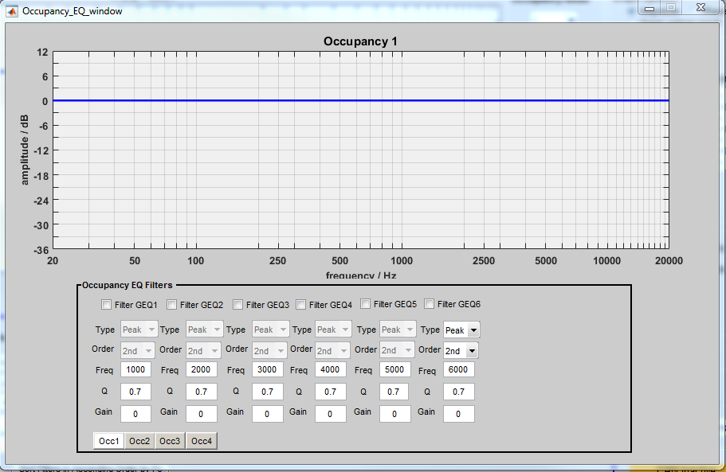

* + For any other DSP implementations:
    - The occupancy EQ filters are a set of 6 filters. They are all double precision full-blown 2nd order filters. These filters are applied to all channels.

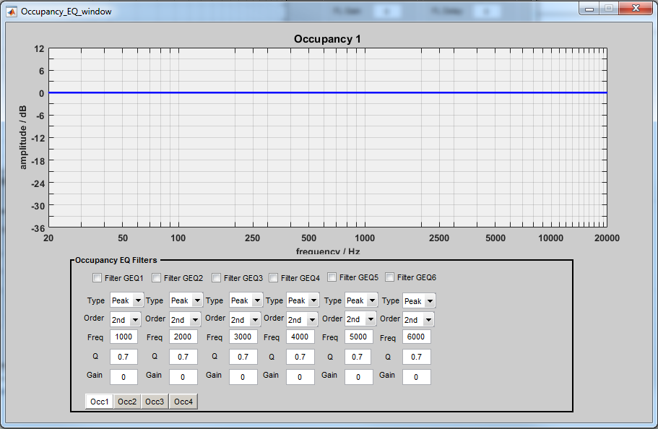

* + These sets of filters are only applied to the respective occupancy modes (i.e. the filters for “Occ2” are only applied when the Occupancy Mode is set to 2).
  + The freq responses in the graph colors match the border of the filter settings and are as follows:
    - Occ1 = Black
    - Occ2 = Red
    - Occ3 = Green
    - Occ4 = Blue
  + The definition of the occupancy modes will be defined per program by the Ford applications D&R in accordance with the PDL and program needs.
  + For most typical programs, the following will be true:
    - Occ1 = All Seats
    - Occ2 = Driver
    - Occ3 = Driver for RHD (or Passenger in the SPSS)
* Chimes
  + Tune
    - The chimes window allows the user to send requests to play chimes with all the same parameters as an IPC_Chime request and the additional Internal Volume setting.
    - The chime request will be sent when pressing “Send” if connected to CAN.
    - This internal volume setting corresponds to the master volume of the chime or the calibrated value that will be stored in the EQ file.

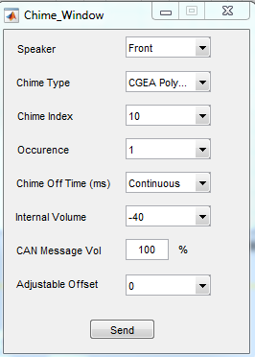

* + Creation
    - This feature has not been implemented yet
* Debug
  + This option allows the user to send the test messages from the API spec for the messages that are not typically used in a tuning session for testing purposes.

1. **CAN**

* Only Matlab supported CAN devices can be used with the tool at this time. The complete list can be found on Mathworks site. The manufacturers are:
  + Vector
  + National Instruments
  + Kvaser
  + PEAK-System
* CAN connect
  + The CAN connect option will bring up a window with all available CAN devices. Select the appropriate device and click OK to start the CAN communication.

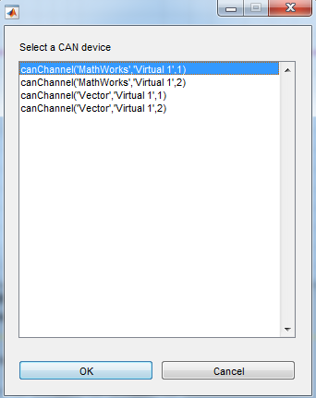

* + The box in the lower right corner of the main GUI will change from saying “CAN Inactive” and being orange to saying “CAN active” and turn green when connected.
* CAN disconnect
  + Pressing this option will close the CAN connection.
* Push Occupancy
  + This option will send all of the data associated with the current occupancy mode selected. So it will send the following:
    - All filters for FL, FR, RL, RR, Aux1, Aux2, Stereo Filters, and Occupancy EQ
    - Limiters
    - Channels Gains
    - Delays
    - Mutes
    - Polarities
    - Volume
    - THD
* Sending CAN data
  + After connecting to CAN, pressing enter in any textbox associated with a setting, pressing any checkbox associated with a setting, or changing a dropdown setting will send the CAN message for that particular setting

1. **VBF**

* Create EQ/Chime Cal vbf
  + This option will create the EQ vbf that corresponds to the EQ File Structure Spec.
  + Depending on which supplier and supplier radio type is selected, the correct version of the structure, start address, and erase size will be used to create the file.
  + The name of the file is the part number.
  + The part number will be truncated to a maximum of 16 characters excluding “-“ and the format should be as follows:
    - xxxx-yyyyyy-zzzzzz
      * xxxx = the program prefix
      * yyyyyy = the base part number
      * zzzzzz = the part number suffix
  + The EU Config section is only required for flashing vbf files for radios that follow the EU IDS (Infotainment Diagnostic Specifiction).
* Create Digital Media Chime vbf
  + This option will create the Digital Media Chime vbf that corresponds to the Digital Media Chime File Structure Spec.
  + The following window will be display:

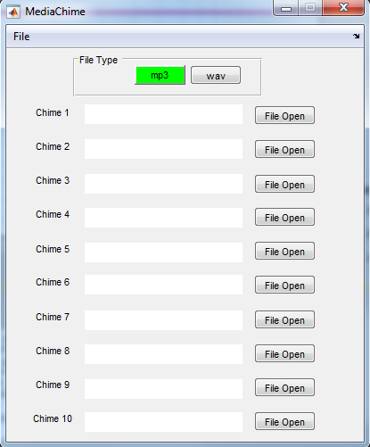

* + The user should press the File Open buttons to select the correct mp3 or wav files for the chimes.
  + The File Type selection will set the correct file length and ensure that the tool checks that all selected files match that type.
  + If wav is selected and wav files are uploaded, the tool will ensure that only the PCM portion of the wav file will be included in the actual vbf.
  + When the user is done loading the files and presses File -> Create Vbf
    - Depending on which supplier and supplier radio type is selected, the correct version of the structure, start address, and erase size will be used to create the file.
    - The name of the file is the part number.
    - The part number will be truncated to a maximum of 16 characters excluding “-“ and the format should be as follows:
    - xxxx-yyyyyy-zzzzzz
      * xxxx = the program prefix
      * yyyyyy = the base part number
      * zzzzzz = the part number suffix

1. **Edit**

* Copy Channel
  + This allows the user to copy one channel to another

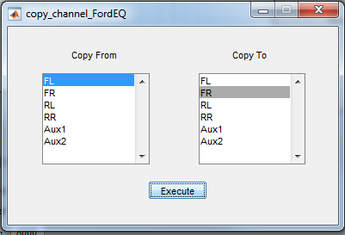

* Copy Occupancy
  + This allows the user to copy one occupancy mode to another

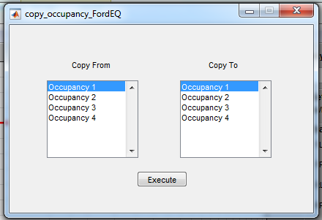

1. **File**

* New
  + This will close the current project and restart the exe
* Open
  + This will close the current project and allow the user to open a different project
* Save As
  + This will allow the user to save the current project
* Edit Project Details
  + This will open the project settings window and allow the user to change all of the following settings of the current project:

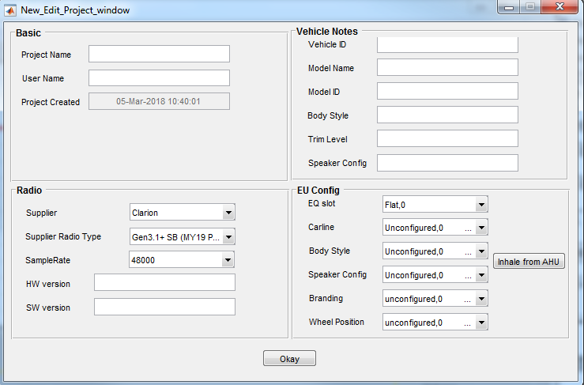

* Import Chimes
  + This will allow the user to select a different project file and only import the chime settings from that project. This will overwrite the chime settings of the current project.
* Preferences
  + Set CAN Delay
    - This allows the user to change the amount of time between CAN messages. The current default is 15 ms. There may be issues with radios not receiving messages if the timing is set to less than 15 ms.

1. **Errors and Troubleshooting**

* If the tool crashes, do not relaunch it. Please send the file “logfile_exeFordEQ” located in the root directory of the install to [mdage@ford.com](mailto:mdage@ford.com)

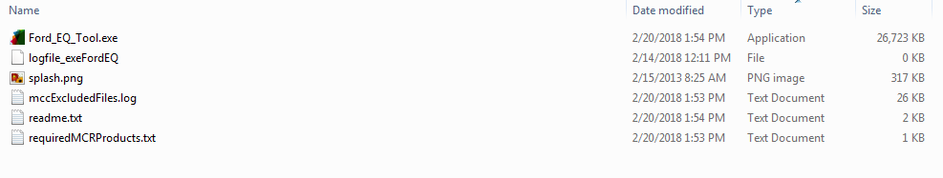

* After sending the file, the user can relaunch the tool.
* For any other errors or issue, contact Matt Dage at [mdage@ford.com](mailto:mdage@ford.com) or 313-57303720 for support.

1. **Revision Log**

|  |  |
| --- | --- |
| V1.0 | 2018-03-06 mdage: Initial Release |
| V1.1 | 2018-03-06 mdage: Added feature/filter specific information for additional implementations other than Dirana (Hero DSPand any other DSP) |